Configure Kibana and Elasticsearch for Dev Setup

Ascendon

Exported on Feb 11, 2022

Table of Contents

1 Elasticsearch 3

2 Download and Install Kibana 4

3 Configure Kibana 6

4 Setup Kibana as a service 7

# Elasticsearch

* Local Elasticsearch should already be installed for all developers and functional. Refer to the following table for the port number:

|  |  |
| --- | --- |
| **ElasticSearch** | **Port** |
| v2.5.4 | 9201 |
| v5.6.8 | 9202 |

* + If it is not installed and functional, please refer to [Elasticsearch 5.6.16 - Local Setup](https://confluence.csgicorp.com/display/Ascendon/Elasticsearch+5.6.16+-+Local+Setup)
* Navigate to <http://localhost:9202> on your favorite browser and you should see something similar to the following:

|  |
| --- |
| {  "name" : "************",  "cluster_name" : "************",  "cluster_uuid" : "siwkreoaskw8tssk",  "version" : {  "number" : "2.4.5",  "build_hash" : "c849dd13904f53e63e88efc33b2ceeda0b6a1276",  "build_timestamp" : "2017-04-24T16:18:17Z",  "build_snapshot" : **false**,  "lucene_version" : "5.5.4"  },  "tagline" : "You Know, for Search"  } |

# Download and Install Kibana

* Download a version of Kibana that works with your local version of Elasticsearch. Refer to the following table for versions which work together:

|  |  |
| --- | --- |
| **Kibana** | **ElasticSearch** |
| v4.6.3 ([Download](https://download.elastic.co/kibana/kibana/kibana-4.6.3-windows-x86.zip)) | v2.4.5 ([Download](https://download.elastic.co/elasticsearch/release/org/elasticsearch/distribution/zip/elasticsearch/2.4.5/elasticsearch-2.4.5.zip)) |
| v5.6.8 ([Download](https://artifacts.elastic.co/downloads/kibana/kibana-5.6.0-windows-x86.zip)) | v5.6.8 ([Download](https://artifacts.elastic.co/downloads/elasticsearch/elasticsearch-5.6.8.zip)) |

* Extract the contents from the zip file to a folder like D:\Apps2
  + Previously this document instructed users to extract to D:\Apps. This is **not** encouraged because that entire folder is under version control and extracting unnecessary files there can make a mess.
  + The path should look something like "D:\Apps2\kibana-5.6.0-windows-x86\config" but the precise naming of the Kibana folder is not significant
* Open "kibana.yml" file found in the "config" folder within the Kibana folder and make following edits:
  + Uncomment the line with the key "elasticsearch.url".
  + Change the value to the Elasticsearch instance. Refer to the following table:

|  |  |
| --- | --- |
| **ElasticSearch Version** | **URL** |
| v2.4.5 | <http://localhost:9201> |
| v5.6.8 | <http://localhost:9202> |

* If it is not already running, start Elasticsearch
* Start Kibana by running "kibana.bat" from the "bin" folder. The output console log should look like the following:

|  |
| --- |
| $ kibana.bat  log [10:01:25.934] [info][status][plugin:kibana@1.0.0] Status changed from uninitialized to green - Ready  log [10:01:25.958] [info][status][plugin:elasticsearch@1.0.0] Status changed from uninitialized to yellow - Waiting **for** Elasticsearch  log [10:01:25.970] [info][status][plugin:kbn_vislib_vis_types@1.0.0] Status changed from uninitialized to green - Ready  log [10:01:25.978] [info][status][plugin:markdown_vis@1.0.0] Status changed from uninitialized to green - Ready  log [10:01:25.981] [info][status][plugin:metric_vis@1.0.0] Status changed from uninitialized to green - Ready  log [10:01:25.993] [info][status][plugin:spyModes@1.0.0] Status changed from uninitialized to green - Ready  log [10:01:25.999] [info][status][plugin:statusPage@1.0.0] Status changed from uninitialized to green - Ready  log [10:01:26.010] [info][status][plugin:table_vis@1.0.0] Status changed from uninitialized to green - Ready  log [10:01:26.027] [info][listening] Server running at http://0.0.0.0:5601  log [10:01:26.029] [info][status][plugin:elasticsearch@1.0.0] Status changed from yellow to green - Kibana index ready |

Code Block 1 Run Kibana

* Validate by navigating to <http://localhost:5601/status> in your favorite browser. You should see something similar to the following:

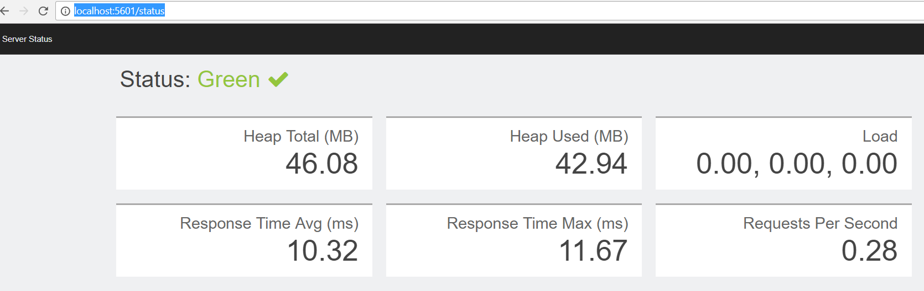

# Configure Kibana

* Navigate to <http://localhost:5601> where you should be see a page to configure an index pattern similar to the following:

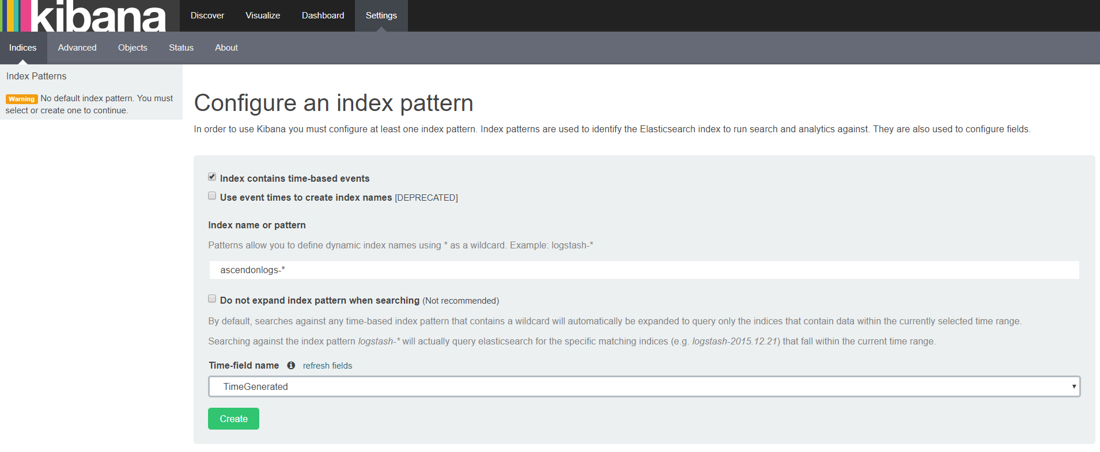

* For logging, use ascendonlogs-* in the index name or pattern
* For tracing, use ascendontrace-* in the index name or pattern
* For either index pattern, use TimeGenerated in the Time-field name
* Click Create
* Click on Discover on the top and select a reasonable time frame to validate that you are able to see the event logs in Kibana

Note that there is no restriction on having both the logging and tracing index patterns, just like both exist in QA/Prod Kibana.

# Setup Kibana as a service

* Stop Kibana running from command prompt
* Download nssm-2.24 from <https://nssm.cc/release/nssm-2.24.zip>
* Extract contents of zip file to D:\Apps2
* Navigate to d:\apps\nssm-2.24\win64 in command prompt
  + If you need to run a Win32 version than navigate to d:\apps\nssm-2.24\win32 instead

|  |
| --- |
| nssm.exe install |

Code Block 2 Run to bring up Installer window

* Supply the path to the "kibana.bat" which you manually ran from command line a few steps ago and the name you want to see in "Services":

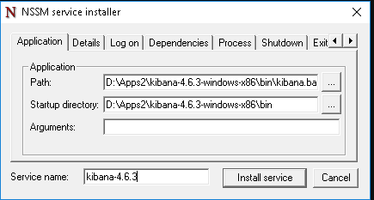

* You can navigate to the dependencies tab above and also make it dependent on your Elastic service like so. The name needs to match the service name in your SCM (Service Control Manager)

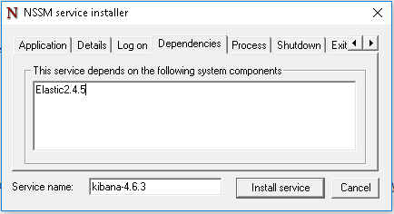

* + Click "Install service" which should setup Kibana as a service
* Open Services Manager and validate that you have the service installed
* Change the startup to Automatic (Delayed Start)

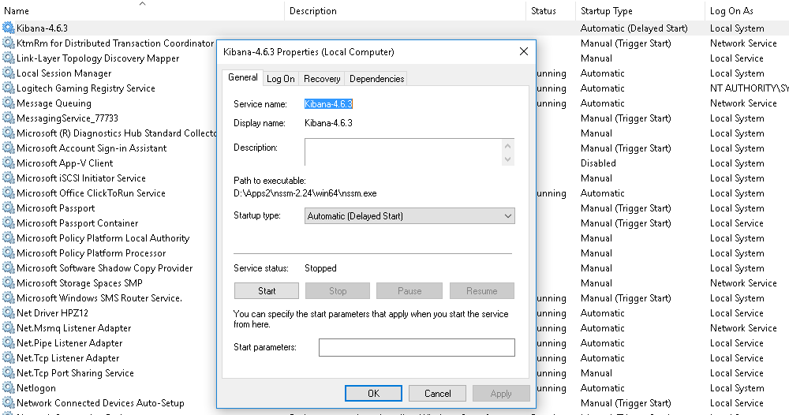

* Start the service and validate that Kibana is functional by navigating to <http://localhost:5601>